Parish Priest: Fr. Mark Croker  Mobile : 0428 190 759  Presbytery 02 8331 7609  Wednesdays- Fr. is at Bombala Parish  Mass: 9.30am & Delegate 2nd Wed 10.30am  Parish Secretary:  Mrs Sharon Nesbitt 02 8331 7608  Office Opening Hours  Mon, Wed & Thu open hours  9am-1pm/ 2pm-4.30pm  Email: cooma@cg.org.au  www.cg,org.au/cooma  Sacramental Program  Fr Mark Croker  0428 190 759  St Patrick's Parish School  Principal:  Mrs Frances Robertson  Cnr Murray & Vale Street, Cooma  Phone: 02 6452 1721  http://stpatscooma.nsw.edu.au  www.facebook.com/stpatscatholicparishcooma  Parish Pastoral Council:  Darren 0429 904 291  www.cg.org.au/cooma  www.cg.org.au/jindabyne  www.cg.org.au/bombala | ST PATRICK’S PARISH FAMILY  Three Parishes Together  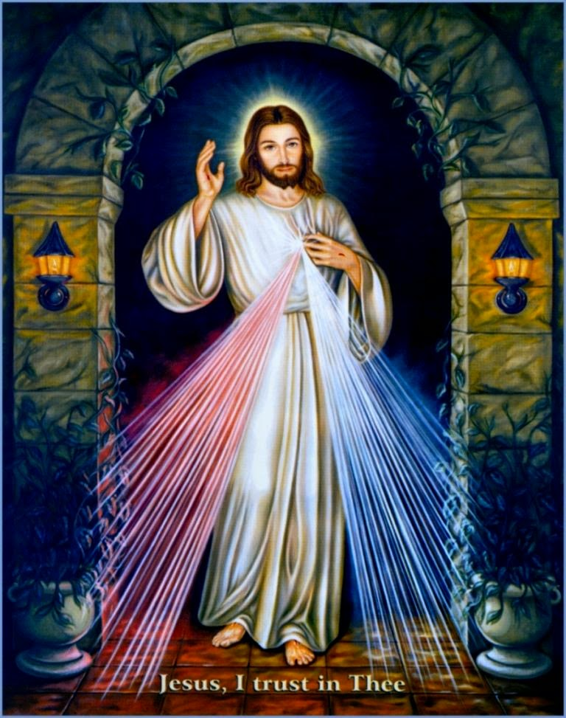  Baptism Request forms can be located on Parish website/at Parish Office, Fr Mark will be available to celebrate during mass on 2nd Sunday of the month | St Patrick’s Cooma Mass  Mass Sunday’s at 10am  Cooma Sacrament of Reconciliation  As requested following Mass  St Patrick’s Weekday  Mass: Tues, Thu, Fri 10am  Except Third Friday of Month Nursing Home Mass  9.30am Yallambee Lodge  11am Sir William Hudson  Adaminaby volunteer required-  Nimmitabel  Mass 3rd & 5th Sunday  *5pm Sat Vigil Mass  1st 2nd,4th Sun- LITURGY Sat 5pm  Numeralla  Mass 4th Sunday at 5.00pm  LITURGY 2nd Sunday 5.00pm  Berridale  Mass 2nd & 4th Sunday of month  Vigil Mass Saturday’s at 3.30pm  1st 3rd & 5th Sunday Liturgy  of the Word 10am Sunday  Jindabyne  2nd 3rd & 4th = Vigil Mass 5pm Sat  1st & 5th Sunday Liturgy 5pm Sat

Roster | 14th April | 21st April
Acolyte | Kaitlyn Bosco | Richard Cmunt
Usher | Pauline Radosavljevic | Kathleen Bashford
Reader/Commentator | Jo-Anne Brown  Joan Simpson | Kathleen Bashford  Paul Mackay
Special Minister | Rafal Zieja | Mike Introna
Mass Servers | Bosco family | …………..
Children’s Mass | School Holidays | School Holidays
Linen |  | Gaie Mooney
Church Care | Blyton & Barrett family | S McPhie L Baker  B Moser
Hospital | Margaret Quodling | Leah Baker

FLOWERS: Claire Neumeyer thank you

Next weekend Readings
Fourth Sunday of Easter / B
1st Reading Acts 4: 8-12
2nd Reading 1 Jn 3: 1-2
Gospel Jn 10: 11-18

BERRIDALE 28th April
Liturgy of the Word at 10am
Device TAP n Go is available in Church entrance for your donations(Archdiocese split 70/30: 1st & 2^{nd JUST TAP!}
Choose donation Amount
Please Pray for our Recently Deceased, “We have loved them in life, let us not forget them in death”: Barry Lollback, Carol Jones, Mary Tozer, Jaroslav ‘Yarra’ Gregor, Archbishop Francis Carroll.
Anniversaries & Special Intentions: “In loving memory of our departed family and our friends those who have no one to pray for them!”
Prayers for our Sick: “We pray for the sick: may they feel the healing power of Christ and find comfort and hope in His constant presence” Tania Giuliani, Don McDonald

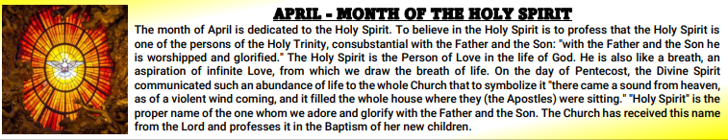
18 May | Marriage Preparation Courses

Upcoming Marriage Preparation courses for engaged couples: Engaged Encounter- Sydney, Sat 18 & Sun 19 Feb. FOCCUS - Tues 11th June 5-9pm plus a private follow up session at CatholicCare. Evenings for the Engaged- Sat 13 & 20 July. SmartLoving – online, 9 lessons, learn at your own pace when suits you. For more information or to register go to www.marriagefamily.org.au Enquiries: Text Helena Zobec on 0405 440 463

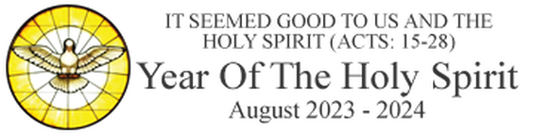
Berridale Rental Available
St Joseph’s Berridale – Tenancy available for the Parish residence adjoining the Church in Mary Street Berridale.
The Unit is a fully furnished 1 bedroom /kitchen /living area with carport – beautifully furnished and recently painted.
$270 pw (incl electricity & Water) Enquiries to the managing agent:
McGrath Estate Agents - Snowy Mountains
Cooma : 02 6452 7004

YEAR OF THE HOLY SPIRIT PRAYER
Prayer to the Holy Spirit for the Archdiocese Thank You, Donation received have raised $3485
O God, who by the light
of the Holy Spirit,
did instruct the hearts
of the faithful,
Grant that by the same
Holy Spirit we may be
​ truly wise and ever rejoice
in his consolations.
Through the same
Christ our Lord.
Amen.

Joke:
A Sunday school teacher was teaching the Ten Commandments to her five and six year olds. After explaining the commandment to "honor thy father and thy mother," she asked,"Is there a commandment that teaches us how to treat our brothers and sisters?"
One little boy shouted, "Thou shall not kill."

